G064 Herbaria Image Measurement Protocol for MaxEnt
Prepared by: Cristopher Ferreon, Kat Tisshaw, Aaron Rhodes
Summary
This protocol outlines obtaining georeferenced GBIF herbaria data and measuring associated plant traits in ImageJ to determine the climatic suitability of large and small form Guinea grass using known morphological trait differences. From the dataset acquired using this protocol, we then use the Presence-absence prediction tool (MaxEnt) in ArcPro to estimate the climatic suitability for each taxon using the known locations associated with global climate patterns.
The protocol is divided into subsections outlining:
1) GBIF download of occurrence records using filters ensuring reliable geographic and taxonomic data
2) Data preparation using multimedia links associated with each occurrence are used to locate and download high-quality images of herbarium vouchers
3) Measuring images in ImageJ from each herbarium specimen occurrence following a consistent scaling procedure for panicle length, leaf width, and seed length. Decision rules are provided for handling missing scales, obscured structures, or absent plant parts.

GBIF download
To access occurrence records of a species of interest through GBIF, go to https://www.gbif.org/, type in the species name in the search bar, and select occurrences (default is “everything”):
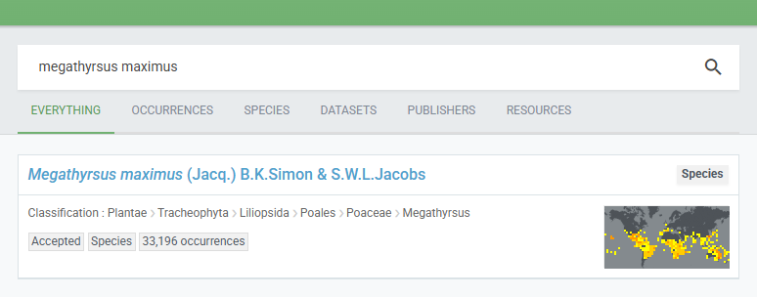
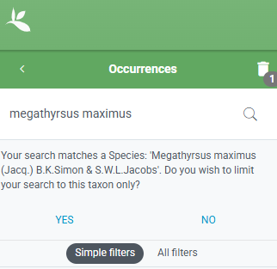
Accept the update to the species name (this ensures that entries follow a specific/approved format for data validity)

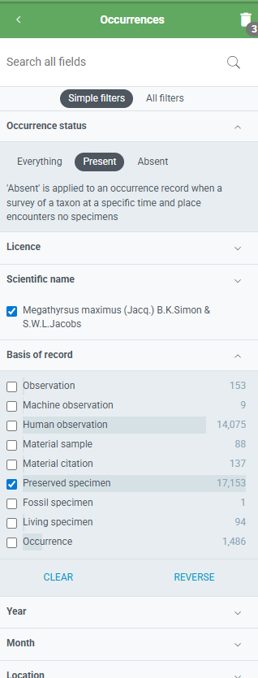
Filter on “Presence” for Occurrence status (this will exclude “Absent” entries from opportunistic searches). Filter on “Preserved specimen” for Basis of record (this ensures that your occurrences are all from preserved herbarium specimens). Leave Year and Month defaulted. For location, specify “Including coordinates”. Leave other sections defaulted up until Issues and Flags (see below)
Other categories for Basis of Record are as follows: Observation: unspecified observer, could be sensor-based, less metadata than human or machine observation (i.e. older/aggregated datasets, legacy monitoring programs)
Machine observation: detected by machine (i.e. camera traps, remote sensing)
Human observation: A direct observation by someone without a collection i.e. from field surveys, notes, or literature. Can’t be confirmed.
Material sample: physical sample that is not a whole organism (i.e., soil/litter samples with grass, eDNA)
Material citation: a reference to, or citation of, one, a part of, or multiple specimens in publication or field notebook. Can’t be confirmed.
Fossil specimen: Not relevant for contemporary climatic suitability
Living specimen: a living plant grown intentionally in cultivation, e.g. botanical garden, experimental plots, not a natural occurrence location, although it could be naturalized/not currently maintained
Occurrence: sort of an “NA” for Basis of Record

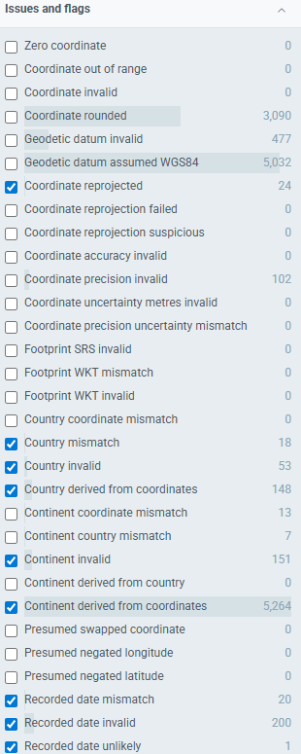
Keep records with the following issues/flags (green font indicates inspection ideal):
Coordinate reprojected: reprojected successfully to WGS84
Country mismatch: Interpreted Country [from coordinates?] and Country code contradict each other
-both country and coordinates are reported by data publisher, and they don’t match; potentially from country/coordinate typo, low coordinate precision, borders/coastal areas, historical/admin change
Country invalid: reported country code has a typo or doesn’t match GBIFs code/list; i.e., “West Africa”
Country derived from coordinates
Continent invalid: reported continent has a typo or doesn’t match GBIF’s list
Continent derived from coordinates
Recorded date mismatch, invalid, or unlikely: typo and/or in the future/before Linnean times, or doesn’t make biological sense (i.e., dinosaur found in 2025). Check, then remove future dates since it indicates suspicious/messy collection
Do not select issues/flags: Coordinate rounded - Geodetic datum invalid - Geodetic datum assumed WGS84 - Coordinate precision invalid - Coordinate uncertainty in metres invalid - Any footprint invalid/mismatch - Continent [or country] coordinate mismatch -
Continent country mismatch - as these all indicate unreliable geospatial data

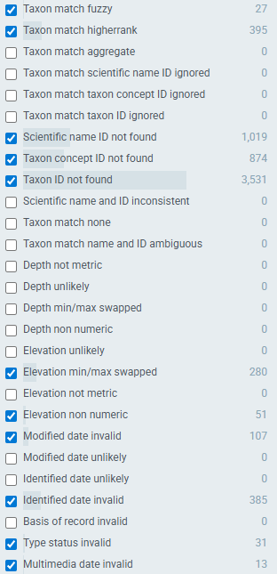
Keep records with the following issues/flags (green font indicates inspection ideal):
Taxon match fuzzy: typo or alias
Taxon match higherrank: typo or alias, but remove records wherein specific species of interest, or variant, is not included
Scientific name ID not found: typo or alias
Taxon concept ID not found: ID formatting errors, recently updated taxon, or mismatch back to Taxon ID
Taxon ID not found: typo or alias, but remove when specific species of interest, or variant, is not included
Elevation min/max swapped: indicates that it might have been a swapping error (since the min is higher than the max) but could also be a typo. Don’t use if you need elevation data specific to that observation, but that wasn’t relevant for our purposes
Elevation non numeric: GBIF expects a number (no units), so it automatically flags text or symbols
Modified or Identified date invalid: date could be invalid (i.e. future, or day “34”), or not in the correct format
Type status invalid: provided specimen type status has typo, formatting error, or not in GBIF’s list (i.e. holotyp instead of holotype)
Multimedia date invalid: date could be invalid (i.e. future, or day “34”), or not in the correct format. Check and remove if it’s in the future or historical

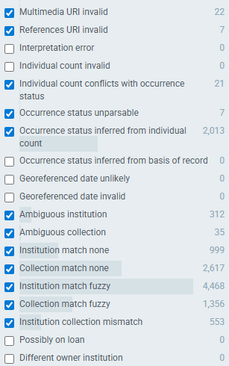
Multimedia URI invalid: for studies measuring traits on herbarium datasheets (which we’re interested in), this means you won’t be able to access the URL with the herbarium sheet scan. You could try to search for the updated URL through the herbarium database online
References URI invalid: reference might have been malformed or have invalid characters
Individual count conflicts with occurrence status: consider removing observations where the count is “0” although the occurrence status is “Present”
Occurrence status unparsable: the value provided is something other than “Present” or “Absent”. Remove any that suggest specimen was absent
Occurrence status inferred from individual count: no occurrence status was provided so anything with a count > 0 is classified as “Present”, otherwise it’s classified as “Absent”
Ambiguous institution: institution code matches more than one institution in GRSciColl or match was uncertain
Ambiguous collection: provided collection code matches multiple collections in GRSciColl
Institution or Collection match none: no match was found in GRSciColl because it doesn’t exist or code is wrong
Institution or Collection match fuzzy: a likely but not exact match between a specimen’s institution or collection code/identifier in a dataset and its entry in GRSciColl
Institution collection mismatch: provided collection code doesn’t match one listed for the specified institution

Data Preparation
The following protocol references the GBIF download for Megathyrsus maximus (Jacq.) B.K.Simon & S.W.L.Jacobs: GBIF.org (7 January 2026) GBIF Occurrence Download https://doi.org/10.15468/dl.u4hgm5

GBIF gives you a zipped file containing txt files and browser html links (see below). First, create .csv files from the occurrence.txt and multimedia.txt files.
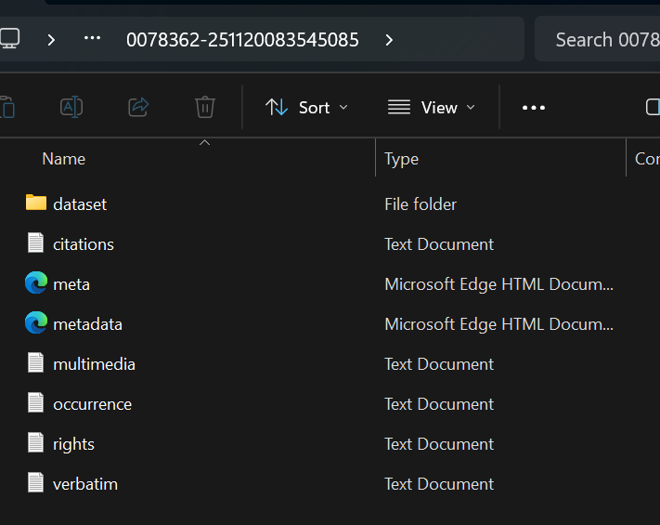
Use this RStudio script to link the two .csv spreadsheets “multimedia” and “occurrence” and perform other data cleaning for the project. You will end up with two spreadsheets, one of which contains occurrences removed from the “master” because of duplicated coordinates. This spreadsheet will be processed after the master is finished, to backfill any occurrences where vouchers could not be accessed and measured.

Using the master spreadsheet, create new columns for your measurements: Panicle length (cm), Leaf width (cm), and Seed length (cm). For readability, highlight the main columns that will be used to find the links to the vouchers to be measured, including:
- identifier
- biblographicCitation
- references_multimedia
- references
- associatedReferences
- occurenceID

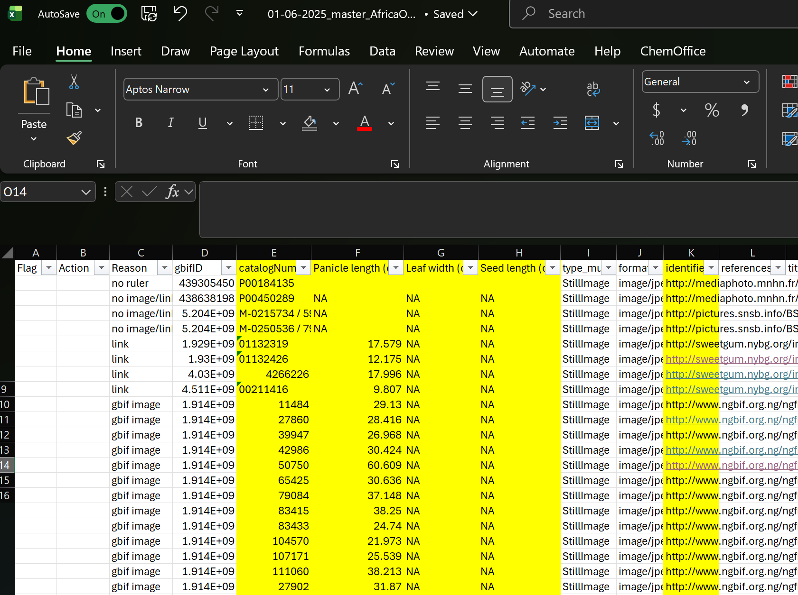
Note that for this specific download, the 6 columns noted above each had at least one occurrence row where a valid link to the herbaria voucher specimen was found only within one of those columns, but this does not mean that in future downloads this is relevant; there may be more or less depending on your search criteria. Any other highlighted columns within the spreadsheets on Box are referenced while processing the data (catalog number, panicle length, leaf width, and seed length).

Once the datasheet is set up, you will need to find images of the preserved specimens and upload them to a separate folder on your desktop. For each occurrence (specimen/image), first try searching up the link in the datasheet: this can be done quickly by double clicking the link in the “identifier” column, then clicking out and back on the link, which should turn blue after clicking out. If this does not work, copy and paste the link into the internet search bar.

If the link does not work, you can return to your GBIF browser (with the search filters still intact from previous section) and search for the specific occurrence using the catalog number pasted into the “Search all fields” bar in the GBIF Occurrence Search. A single result should pop up; if there are multiple results, click the topmost option and check that the catalog number under the “Occurrence” heading matches.
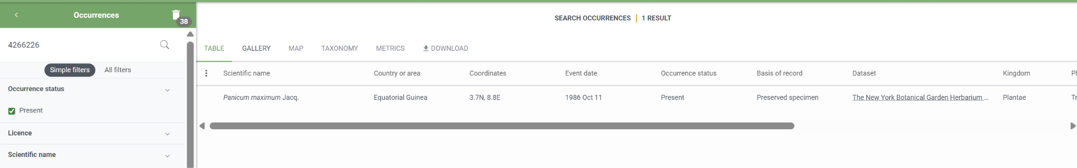
After clicking on the occurrence result, there should be one or a few images of the sample. If not, or the image is unusable (not a preserved specimen, unclear image, etc.), mark this down on the datasheet and continue to the next occurrence row.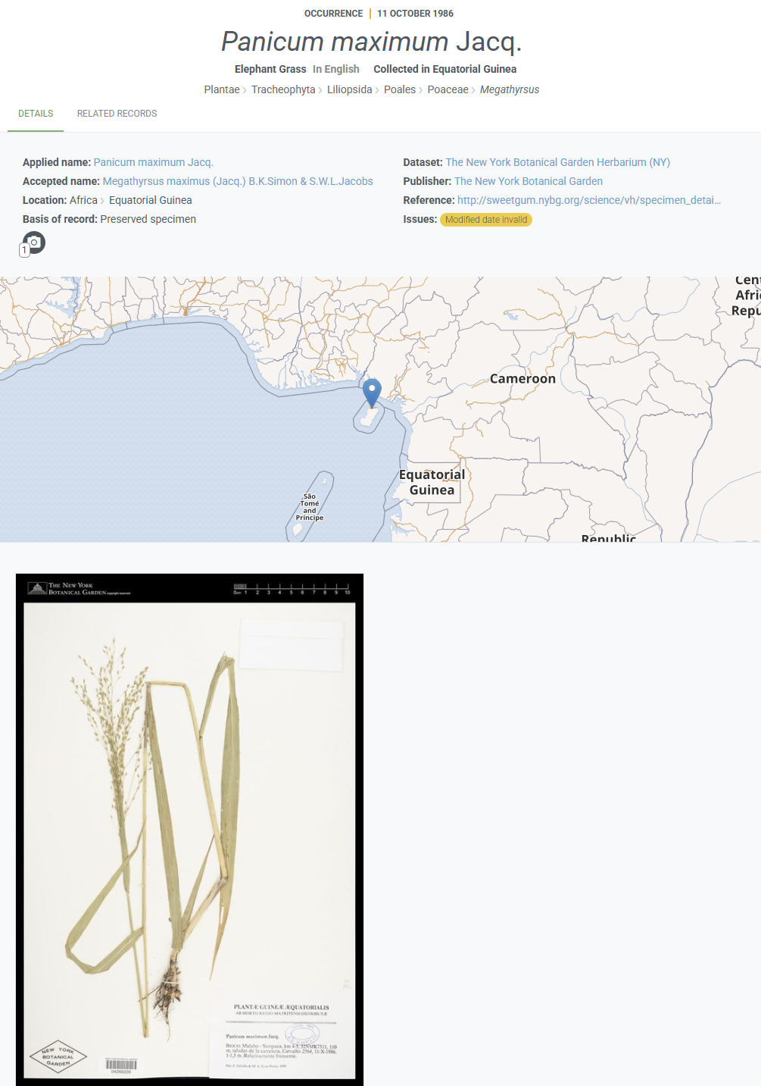

Save the images into your computer’s designated folder. Within that folder, you can name each of the images by their catalog number to find them more easily.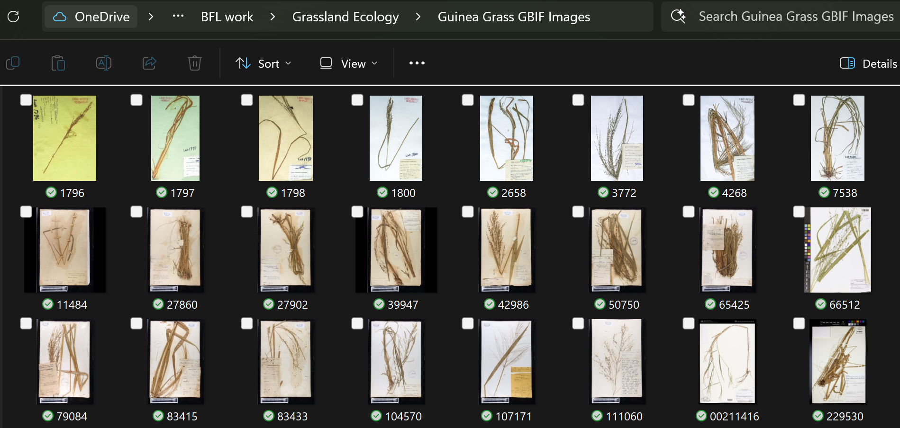

Measuring Images in ImageJ
Once you have uploaded the images into a designated folder, you can begin measuring them in ImageJ. Reference this protocol if you have not downloaded or are not familiar with working in the ImageJ program: ImageJ protocol.docx

Open ImageJ and click on the “File” tab to open a dropdown menu, then click on the “Open…” option. The key shortcut for this is Ctrl + O.
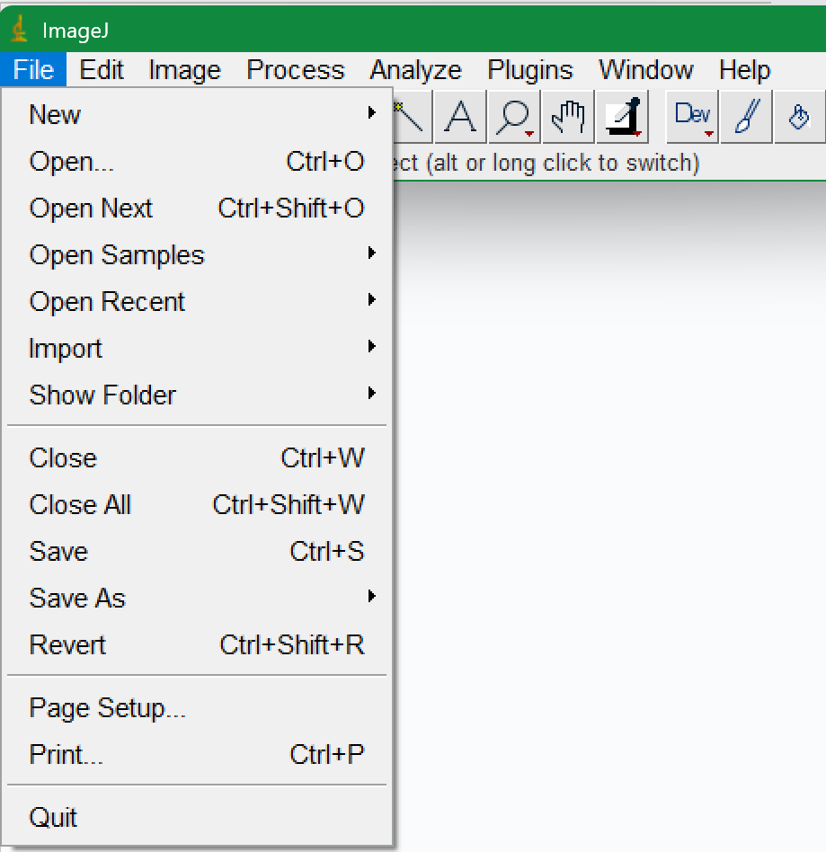

From this, navigate to your designated folder and find the image you are looking for, either by scrolling through the images or by looking up the image name. Note, it’s helpful to have named the images by their catalog numbers, so you are able to copy and paste the number to quickly find the image.
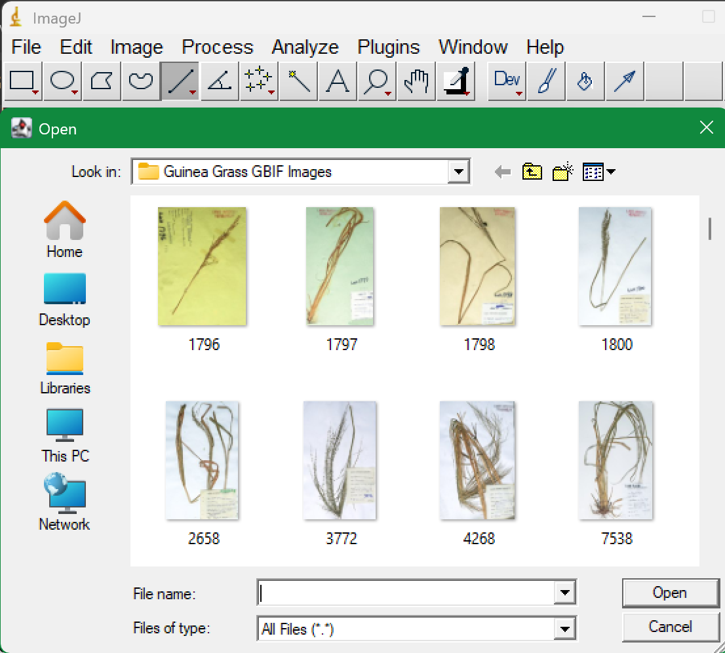
Once the image is open in ImageJ, and if the image contains a visible ruler or scale bar, continue to Calibrate Herbaria Sheet with scale step.
If there is no scale bar but the full paper sheet visible and appears to be standard size, we can assume the sheet width is the standard size of 29cm; continue to the Calibrating Herbaria sheet with no scale step. If the full paper sheet is not visible or sheet dimensions look off, do not take measurements, mark all traits as NA and note “no scale” or anything else applicable.

Calibrate Herbaria Sheet with Scale
Using the “Straight Line” tool, which you can find by right clicking the 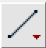 icon, measure the ruler: zoom in to a small section of it, then click and drag using the line tool from one hatch mark to the next, noting the units of measurement and making the line as straight as possible. In the image below, one centimeter of the ruler is being measured.
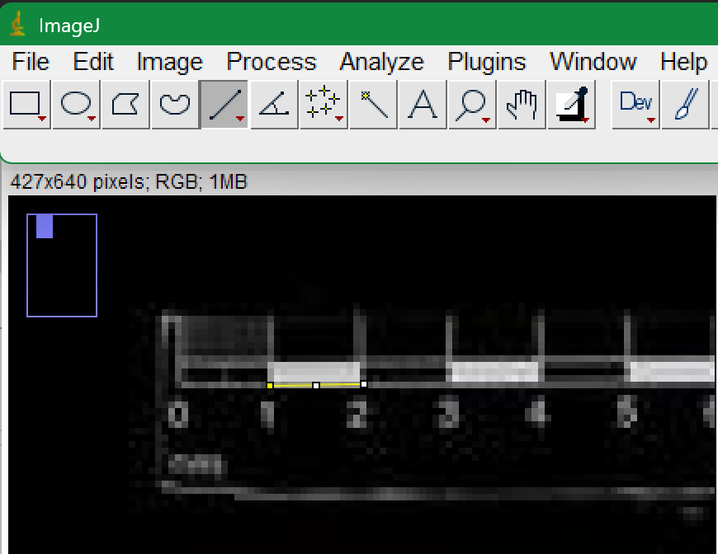

After the line is made, click the “Analyze” tab on the ImageJ window, then select the “Set Scale” tab. Once the new tab (pictured below) appears, change the known distance to 1. You may change the unit of length to match the desired units (in this case cm), but it is not necessary. Click OK to confirm the scale input. In the example, the scale has now been set to 14.2522 pixels per 1 cm distance.
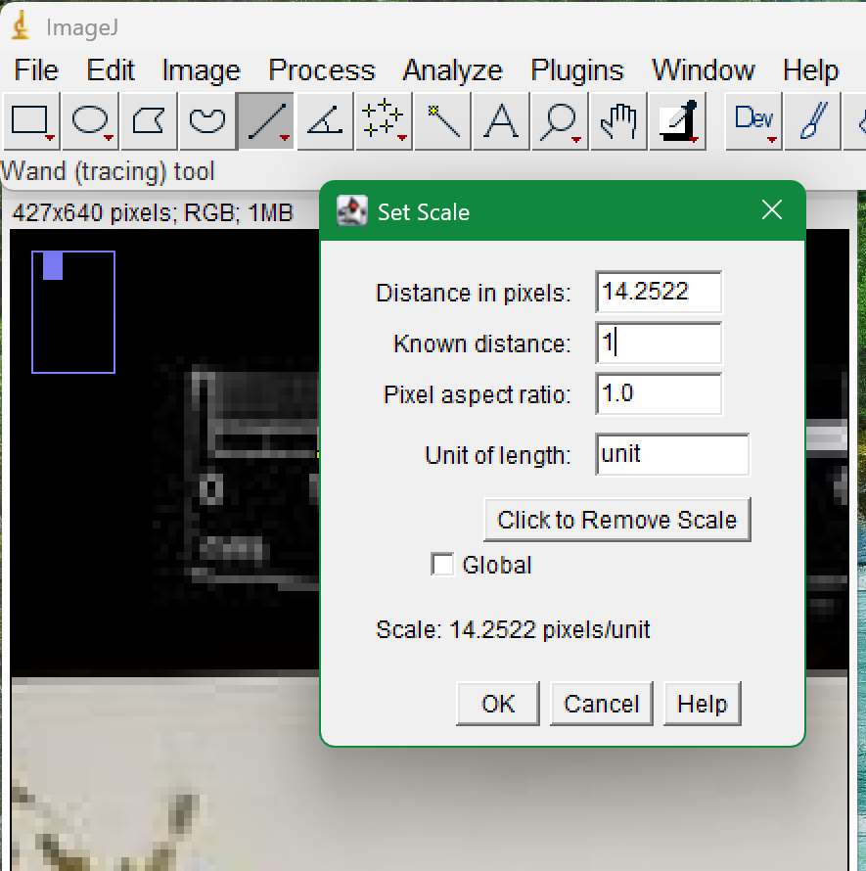

Calibrate Herbaria Sheet with No Scale
1. Use the “Straight Line” tool to measure a line across the full width of the paper.
2. Go to “Analyze” à “Set Scale”.
3. Enter the known distance (29) and add units (optional, cm).
4. Click OK to confirm scale.
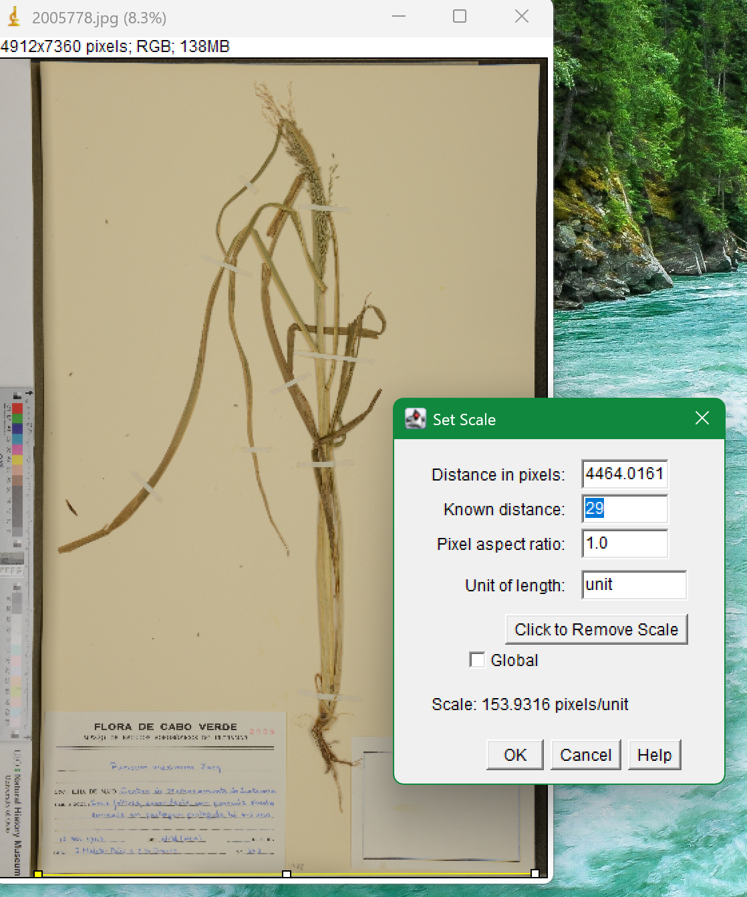

Measuring Images of Guinea Grass
The measurements taken are panicle length, leaf width, and seed length. Below are some definitions and images as a reference for Guinea grass physiology.

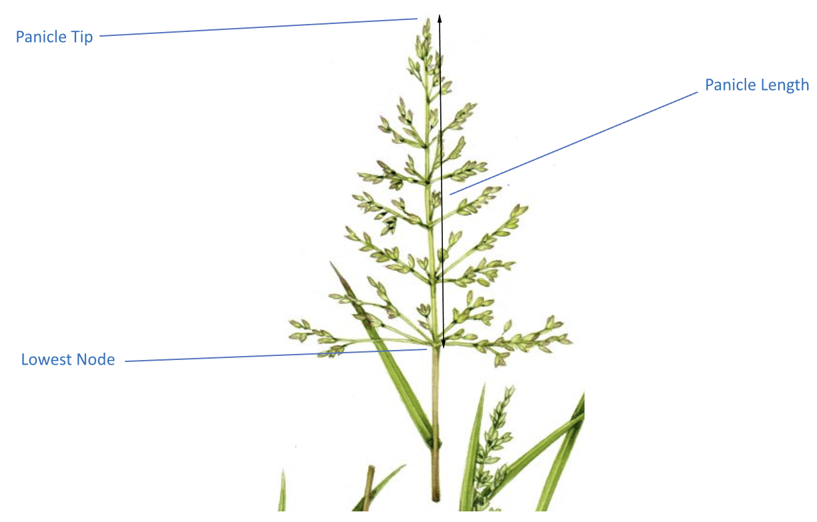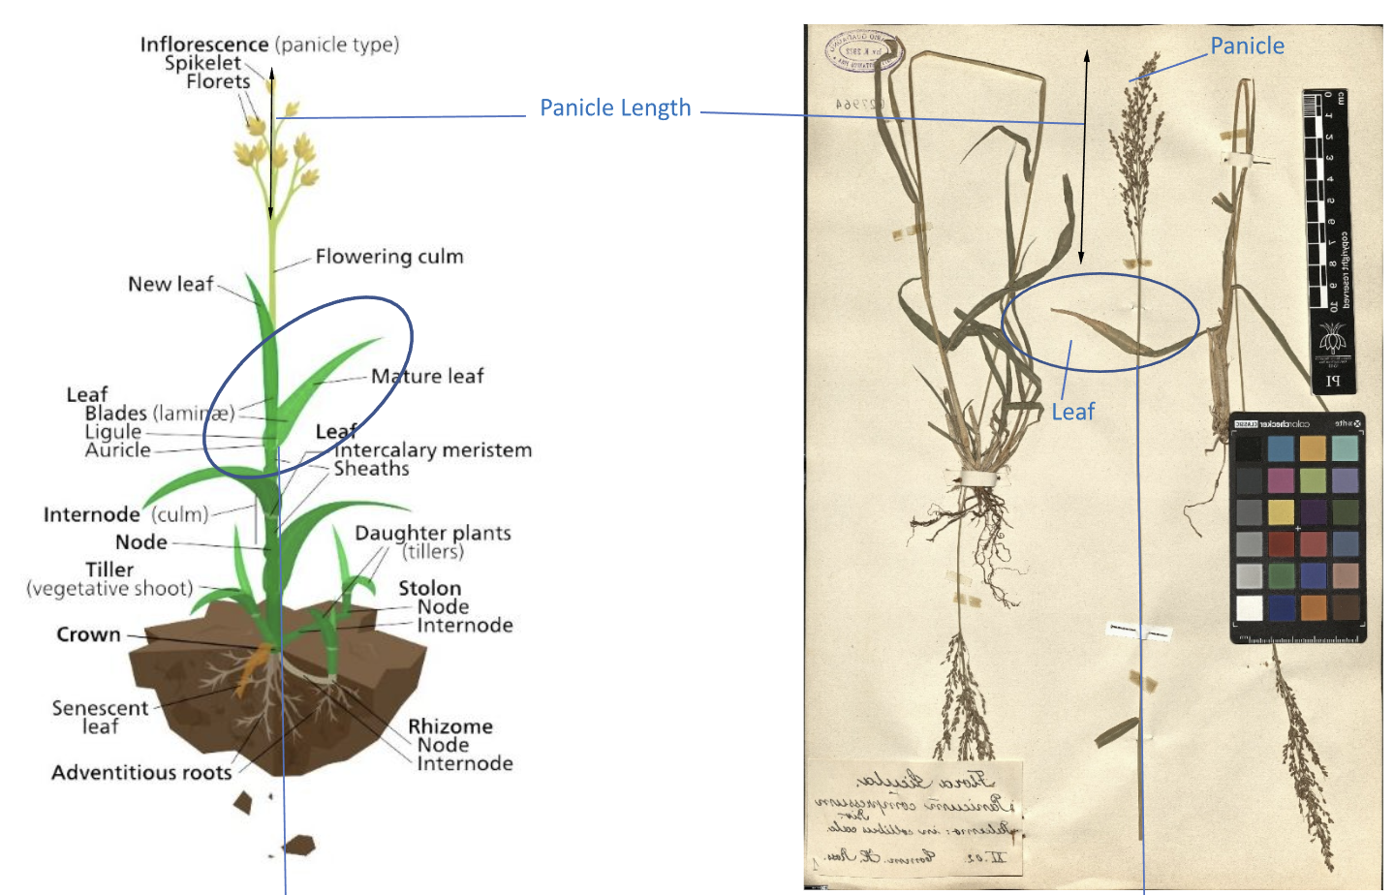
Panicle length: From the lowest panicle node to the tip of the panicle
- Panicle: flowering portion of grass
- Node: a point from which plants branch
Leaf width: from margin to margin at the widest point of the leaf
- Margin: the outer edge of a leaf
Seed length: from the point at which the seed branches out to the tip
- Seed: each enclosed capsule at the end of each branching point

In the ImageJ toolbar, switch the line tool to “Segmented Line” to ensure accuracy when measuring plant/grass images. For this tool, click to start a line and click again to add a new section of the same line. Trace the structure carefully. To end the segmented line, double click in place at the end of the last measurement. Press Ctrl + M to get the measurement in the desired units under the “Length” label.
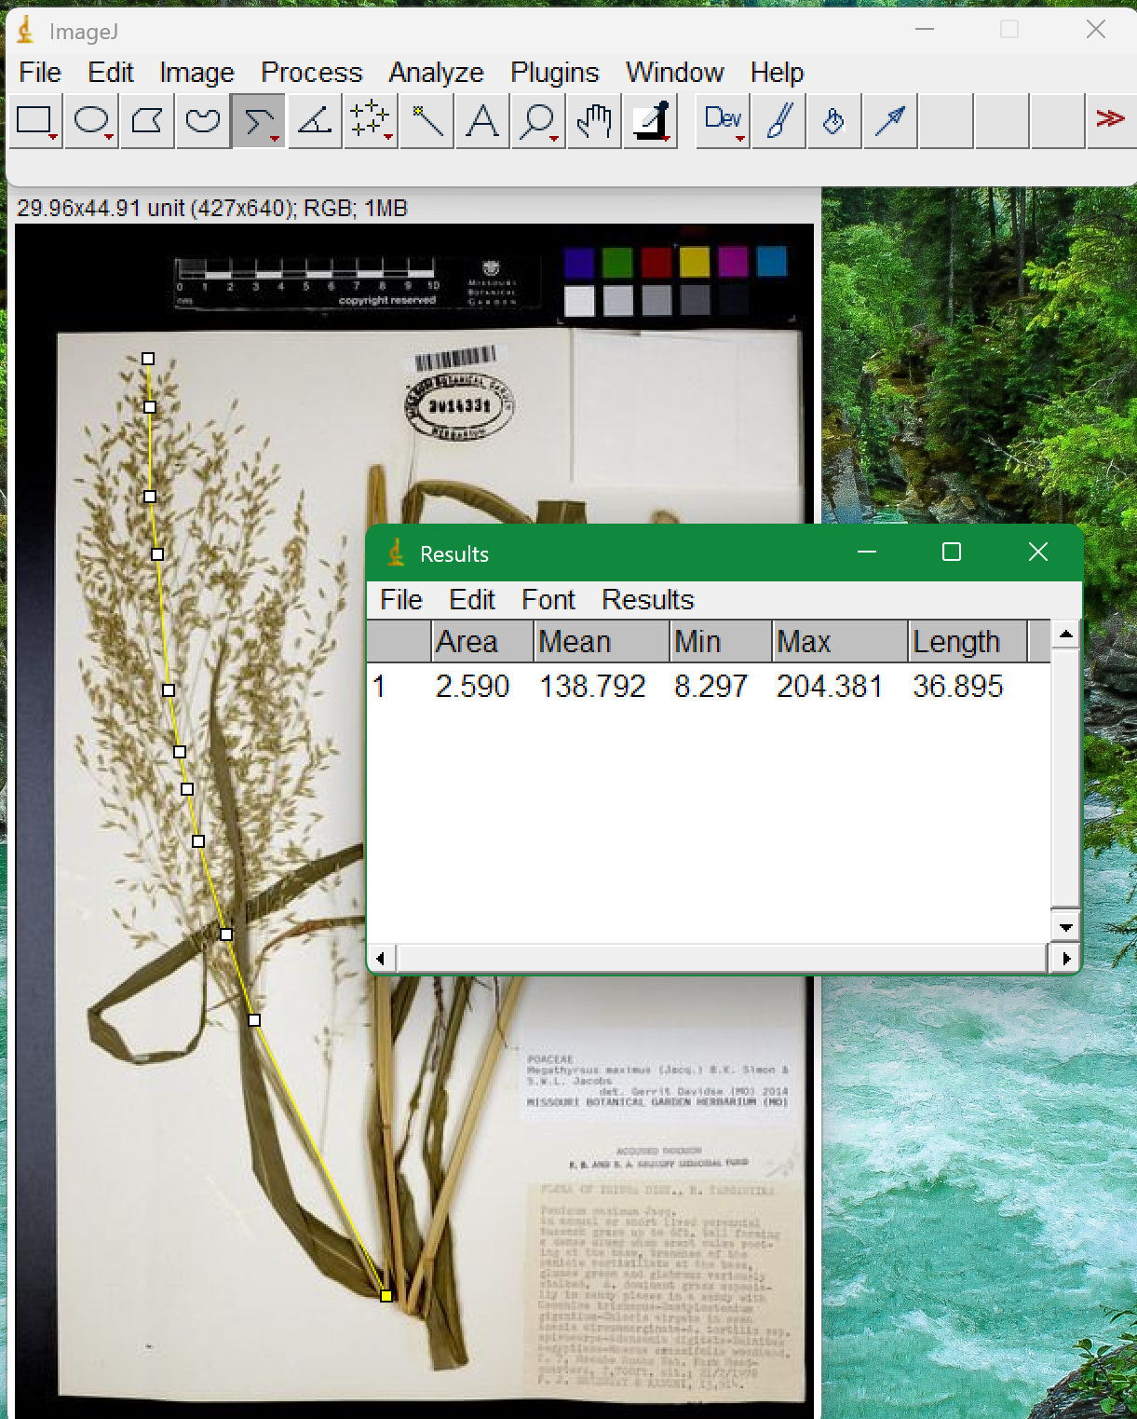

Examples of leaf width and seed length:
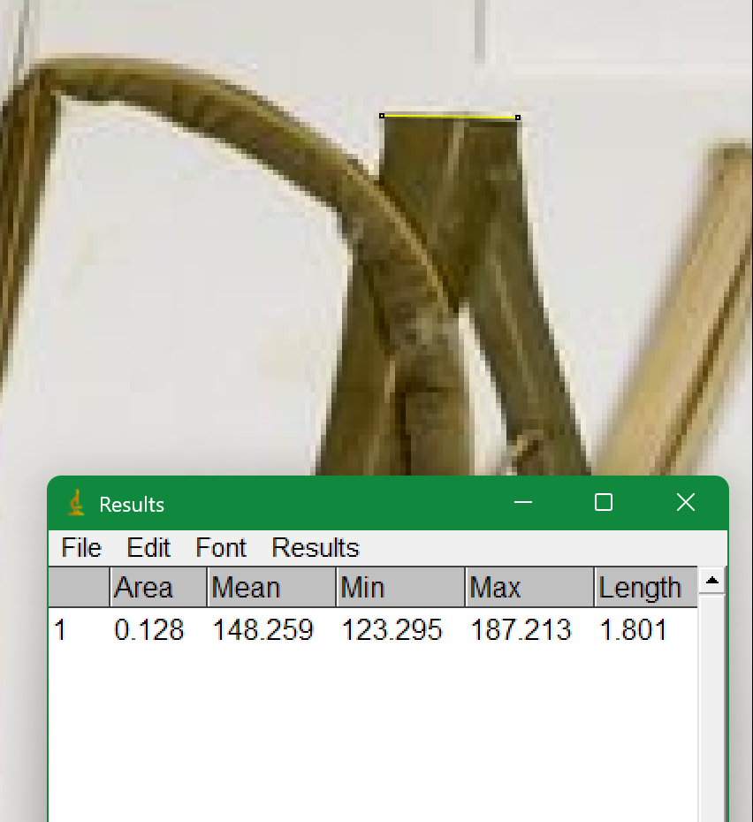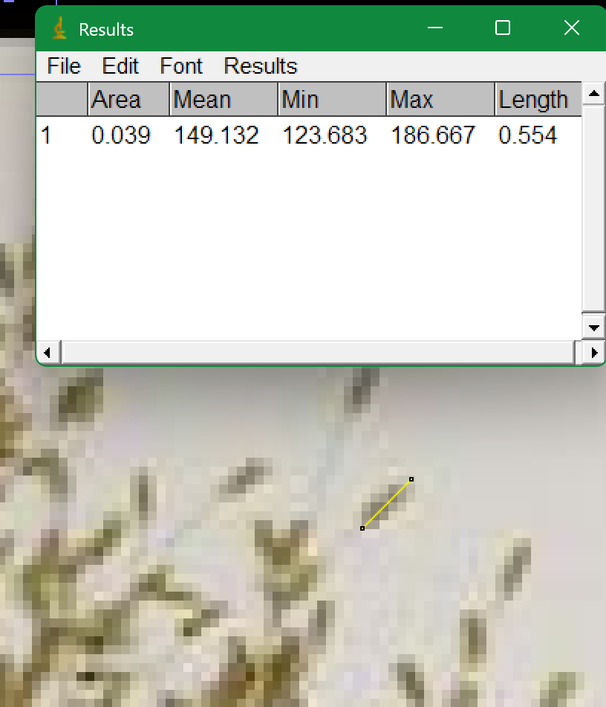
Record the measurements in the appropriate spreadsheet column.
Note: Make sure that the structures are visible and measurable before recording measurement. If not, record NA in the datasheet for that measurement and add a note explaining why (no leaves/seeds, panicle unseen, image unclear, etc.). Examples of other issues you may encounter, and unmeasurable structures, are outlined below.
If the panicle of a sample is folded or covered, it may be helpful to look at the seeds and estimate where they taper in towards the stem, and measure from there.
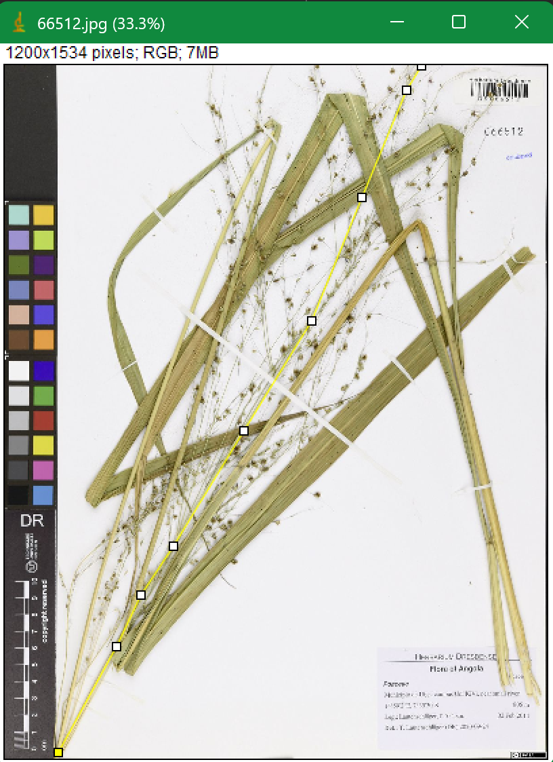

If a sample specimen does not have any leaves or seeds (or instead has flowers), mark those measurements as NA in the datasheet and make a note.
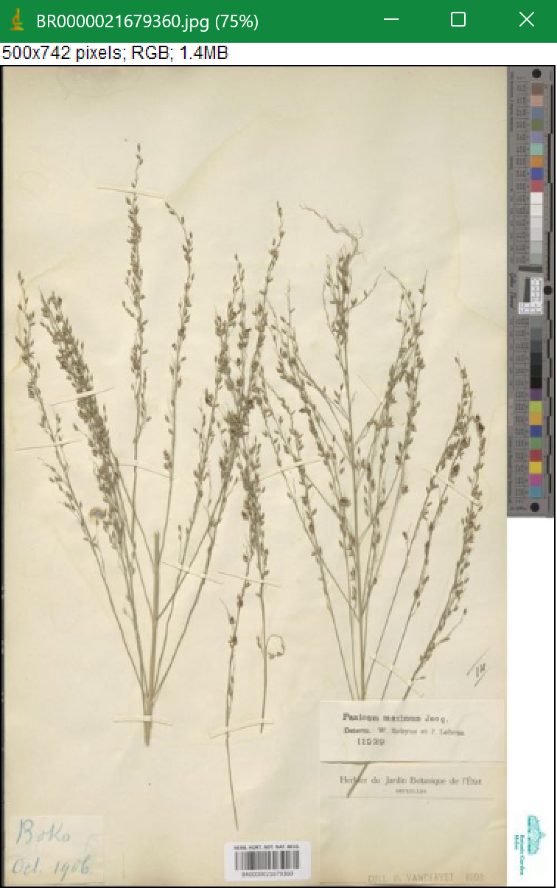
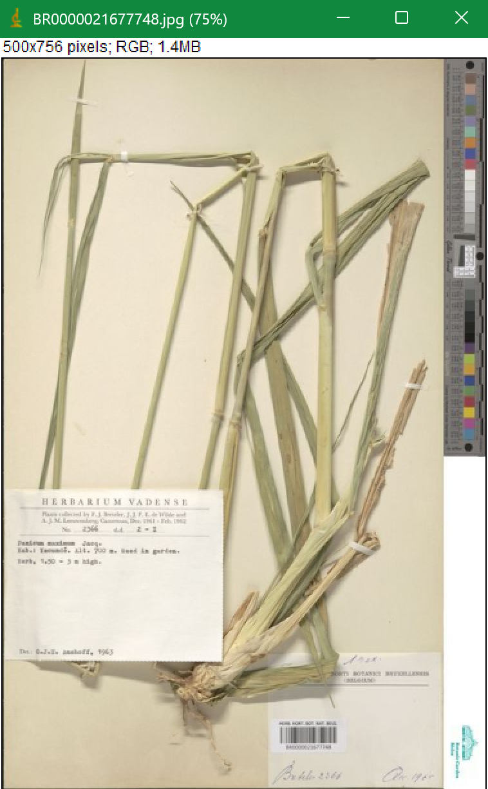
No seeds No leaves

